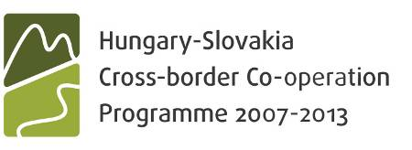

**HUSK/1101/1.6.1**

’Cross-boarder qualification of economists in distance learning network’ (CROSSEDU)

**Aim of the project:**

Comprehensive objective: the increase of economic competitiveness of cross-boarder backward subregions by the common development of human resources.

Specifired pbjective: the strengthening of flexible labour force needed to the integrated labour market for the planning and management of entrepreneurial and municipal development projects, building networks and common qualification of professionals capable for the increase of territorial competitiveness in distance learning network.

**Partners participating in the realisation of the project:**

Subsidised partners:

* University of Miskolc (lead applicant)
* Technická Univerzita v Košiciach (cross-boarder leading partner)

Non-subsidised cooperating partners

* Združenie za Spoločné Ciele? Szövetség a Közös Célokért
* Zempléni Regionális Vállalkozásfejlesztési Alapítvány
* Abaúji Gazdaság- és Vállalkozásfejlesztési Alapítvány
* Ózdi Vállalkozói Központ és Inkubátor Alapítvány
* Regionálna Rozvojová Agentúra Moldava nad Bodvou
* Regionálna Rozvojová Agentúra v Kráľovskom Chlmci
* Csereháti Településszövetség

**Expectable results of the project:**

14 distance learning materials will be elaborated for three common professional courses due to the result of the professional cooperation between the two universities. Materials will be available in English, Hungarian and Slovak for corporate leader, European entrepreneurial and municipal and subregional manager students. 16 case studies, a systematic database and document library are available. To make the qualification technically feasible both universities will be equipped with classrooms ideal for distance learning and infrastructure with the aim of facilitating the involvement in videoconferences and practical trainings at 4 subregional points of both sides of the boarder. The qualification with less modifications of the existing materials of the three courses in groups of 16-20 persons could be upheld till 8 years due to the recruitment carried out by the assistance of the cooperating partners. Meanwhile around 600 students can be trained. Regional developments elaborated and realised by them will expectedly affect the whole region.

**Studies, publications related to the project:**

**Institute colleagues being involved in the project:**

Dr.G.Fekete Éva – project leader

Lipták Katalin – project manager assistent

Hegyi-Kéri Ágnes – financial assistent